Week-5 (DAY-23) Hands-On – Keerthivasan R
Level-1 Problem 1:
Scenario
A financial application needs to process multiple reports simultaneously to reduce waiting time. Instead of executing tasks sequentially, the system should run them concurrently using C# Tasks so that reports are generated faster.
Requirements
- Create three methods:
  - GenerateSalesReport()
  - GenerateInventoryReport()
  - GenerateCustomerReport()
- Each method should simulate processing time using Thread.Sleep() or Task.Delay().
- Execute all three operations concurrently using Task.
- Display a message when each report starts and when it finishes.
- Display a final message once all reports are completed.
Technical Constraints
- Use Task class from System.Threading.Tasks.
- Use Task.Run() to execute methods.
- Use Task.WaitAll() or await Task.WhenAll() to wait for completion.
- The program must run in a Console Application.
Expectations
The program should start multiple report-generation tasks simultaneously and display completion messages for each report along with a final message once all tasks are completed.
Learning Outcome
Students will learn:
- How to create and run Tasks in C#
- How to execute multiple operations concurrently
- How to wait for multiple tasks to complete
CODE:
using System;
using System.Collections.Generic;
using System.Text;

namespace HandsOnDAY_23
{
internal class Problem_01
{
static void GenerateSalesReport()
{
Console.WriteLine("Sales report started...");
Thread.Sleep(2000);
Console.WriteLine("\nSales report completed");
}

static void GenerateInventoryReport()
{
Console.WriteLine("Inventory report started");
Thread.Sleep(3000);
Console.WriteLine("Inventory report completed");
}

static void GenerateCustomerReport()
{
Console.WriteLine("Customer report started");
Thread.Sleep(2500);
Console.WriteLine("Customer report completed");
}

static void Main(string[] args)
{
Task t1 = Task.Run(() => GenerateSalesReport());
Task t2 = Task.Run(() => GenerateInventoryReport());
Task t3 = Task.Run(() => GenerateCustomerReport());

Task.WaitAll(t1, t2, t3);

Console.WriteLine("\nAll reports are generated successfully!");
}

}
}
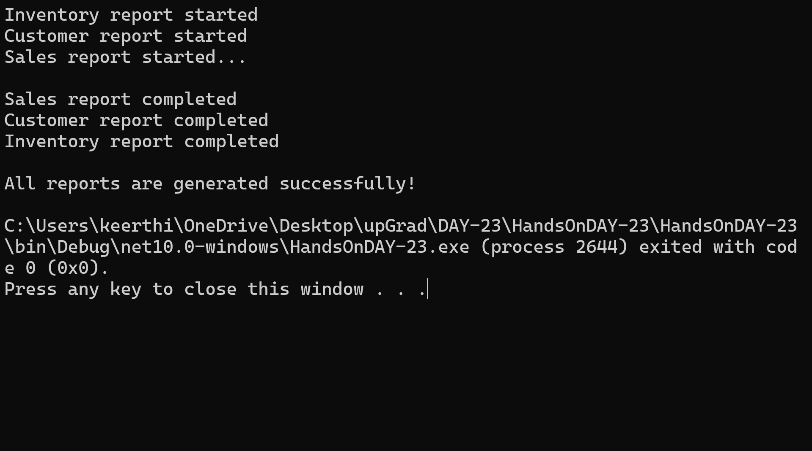
OUTPUT:
Level-1 Problem 2: Asynchronous File Logger
Scenario:
An application writes logs to a file whenever an event occurs. Writing logs synchronously can slow down the application. Asynchronous file writing improves performance.
Requirements:
- Create an asynchronous method WriteLogAsync(string message).
- The method should simulate file writing using Task.Delay().
- Call this method multiple times to simulate logging different events.
Technical Constraints:
- Use async and await keywords.
- Use Task.Delay() to simulate file I/O.
- Use a console application.
Expectations:
- Logs should be written asynchronously.
- The main thread should remain responsive while logging operations occur.
Learning Outcome:
Students will learn how asynchronous operations improve performance when dealing with I/O operations.
CODE:
using System;
using System.Collections.Generic;
using System.Text;

namespace HandsOnDAY_23
{
internal class Problem_02
{
static async Task WriteLogAsync(string message)
{
Console.WriteLine("\nWriting Log: " + message);
await Task.Delay(1000);
Console.WriteLine("\nLog Written: " + message);
}

static async Task Main(string[] args)
{
Task t1 = WriteLogAsync("User logged in");
Task t2 = WriteLogAsync("File uploaded");
Task t3 = WriteLogAsync("Error occured");

await Task.WhenAll(t1, t2, t3);

Console.WriteLine("\nAll logs written successfully");
}
}
}
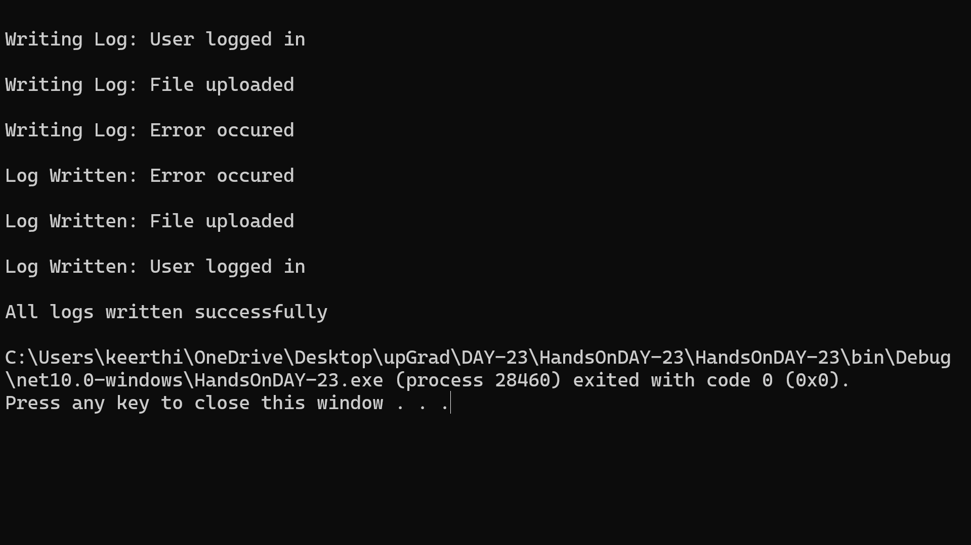
OUTPUT:

Level-2 Problem 1: Asynchronous Order Processing System
Scenario:
An e-commerce system processes customer orders. Each order requires multiple steps such as payment verification, inventory check, and order confirmation. These steps involve delays and should be handled asynchronously.
Requirements:
- Create asynchronous methods:
- VerifyPaymentAsync()
- CheckInventoryAsync()
- ConfirmOrderAsync()
- Simulate processing delays using Task.Delay().
- Execute steps asynchronously while maintaining the logical order of operations.
Technical Constraints:
- Use async and await.
- Use Task-based asynchronous methods.
- Implement using a console application.
Expectations:
- Each processing step should run asynchronously.
- The program should display messages indicating the progress of order processing.
Learning Outcome:
Students will understand how to design real-world workflows using asynchronous methods with async/await.
CODE:
using System;
using System.Collections.Generic;
using System.Text;

namespace HandsOnDAY_23
{
internal class Problem_03
{
static async Task VerifyPaymentAsync()
{
Console.WriteLine("Verifying Payment");
await Task.Delay(2000);
Console.WriteLine("Payment Verifed");
}

static async Task CheckInventoryAsync()
{
Console.WriteLine("\nChecking Inventory");
await Task.Delay(2000);
Console.WriteLine("Inventory Available");
}

static async Task ConfirmOrderAsync()
{
Console.WriteLine("\nConfirming Order");
await Task.Delay(2000);
Console.WriteLine("Order Confirmed");
}

static async Task Main(string[] args)
{
await VerifyPaymentAsync();
await CheckInventoryAsync();
await ConfirmOrderAsync();

Console.WriteLine("\nOrder Process Completed");
}
}
}
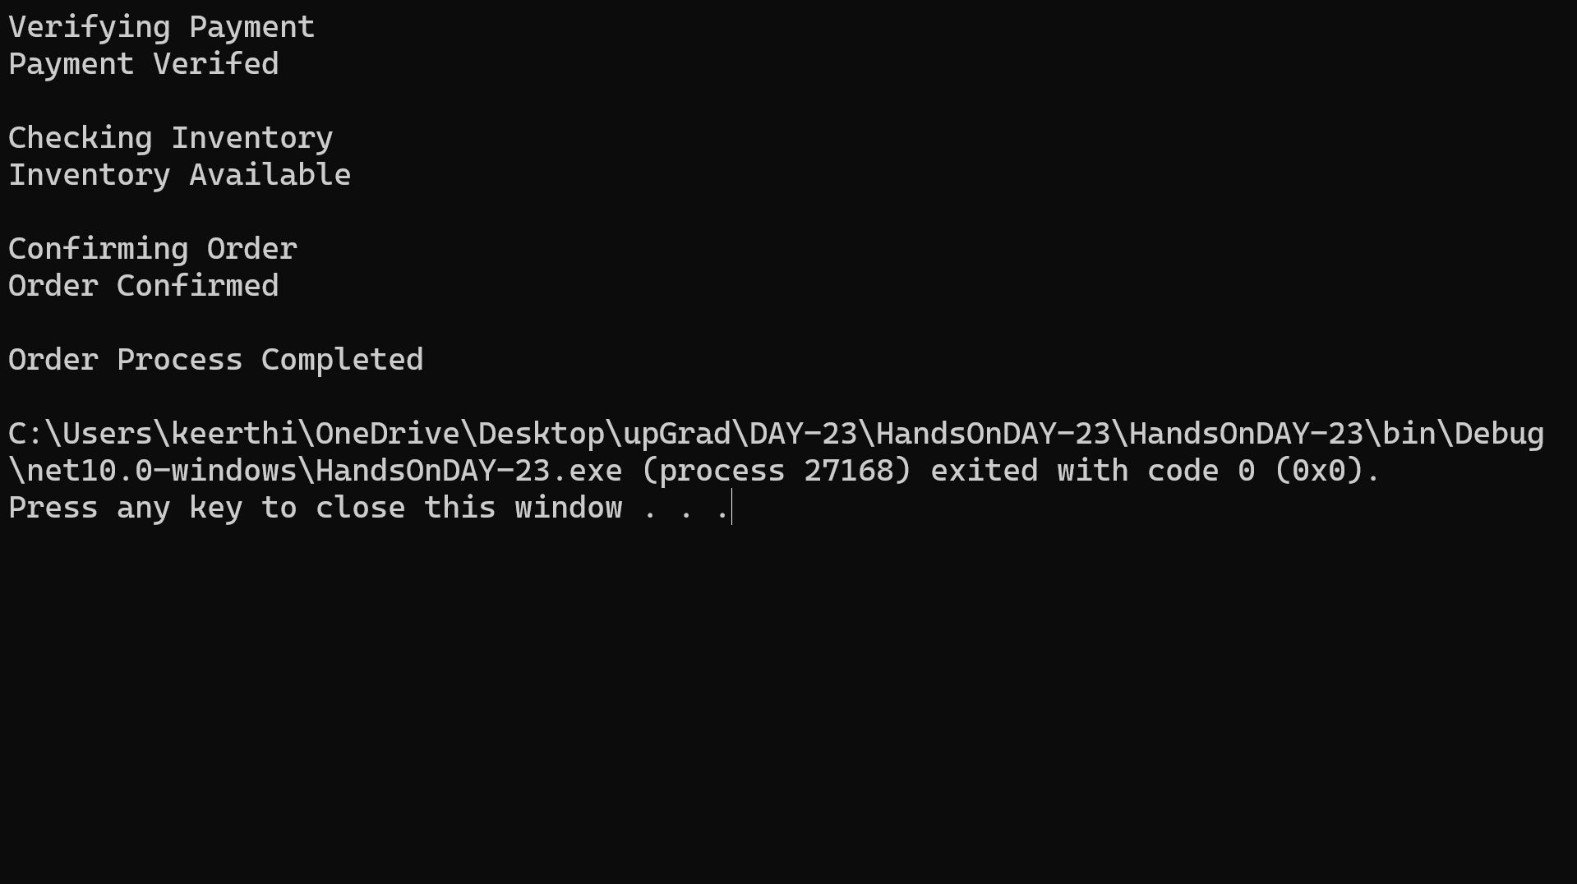
OUTPUT:

Level-2 Problem 2: Debugging Incorrect Discount Calculation
Scenario
A retail application calculates the final price of products after applying a discount. Recently, users reported that the final price shown by the application is incorrect. The development team needs to debug the application to identify where the incorrect calculation is happening.
Requirements
- Create a console application that calculates the final product price.
- The program should accept:
  - Product Name
  - Product Price
  - Discount Percentage
- The final price should be calculated using the formula:
FinalPrice = Price − (Price × Discount / 100)
- Use debugging tools to verify that the calculation is correct.
- Place breakpoints and inspect variable values during execution.
Technical Constraints
- Use Visual Studio Debugging Tools.
- Use breakpoints, step over, step into, and watch window.
- Implement the solution using a .NET console application.
Expectations
- Students should run the program in debug mode.
- They should track variable values and confirm that the discount calculation is correct.
- If incorrect results appear, students should identify the faulty logic.
Learning Outcome
Students will learn how to:
- Use breakpoints effectively.
- Inspect variable values during program execution.
- Identify logical errors using debugging techniques.
CODE:
using System;
using System.Collections.Generic;
using System.Text;

namespace HandsOnDAY_23
{
internal class Problem_04
{
static void Main(string[] args)
{
Console.Write("Enter Product Name: ");
string name = Console.ReadLine();

Console.Write("Enter Price: ");
double price = Convert.ToDouble(Console.ReadLine());

Console.Write("Enter Discount %: ");
double discount = Convert.ToDouble(Console.ReadLine());

// breakpoint
double finalPrice = price - (price * discount / 100);

Console.WriteLine("Final Price: " + finalPrice);
}
}
}
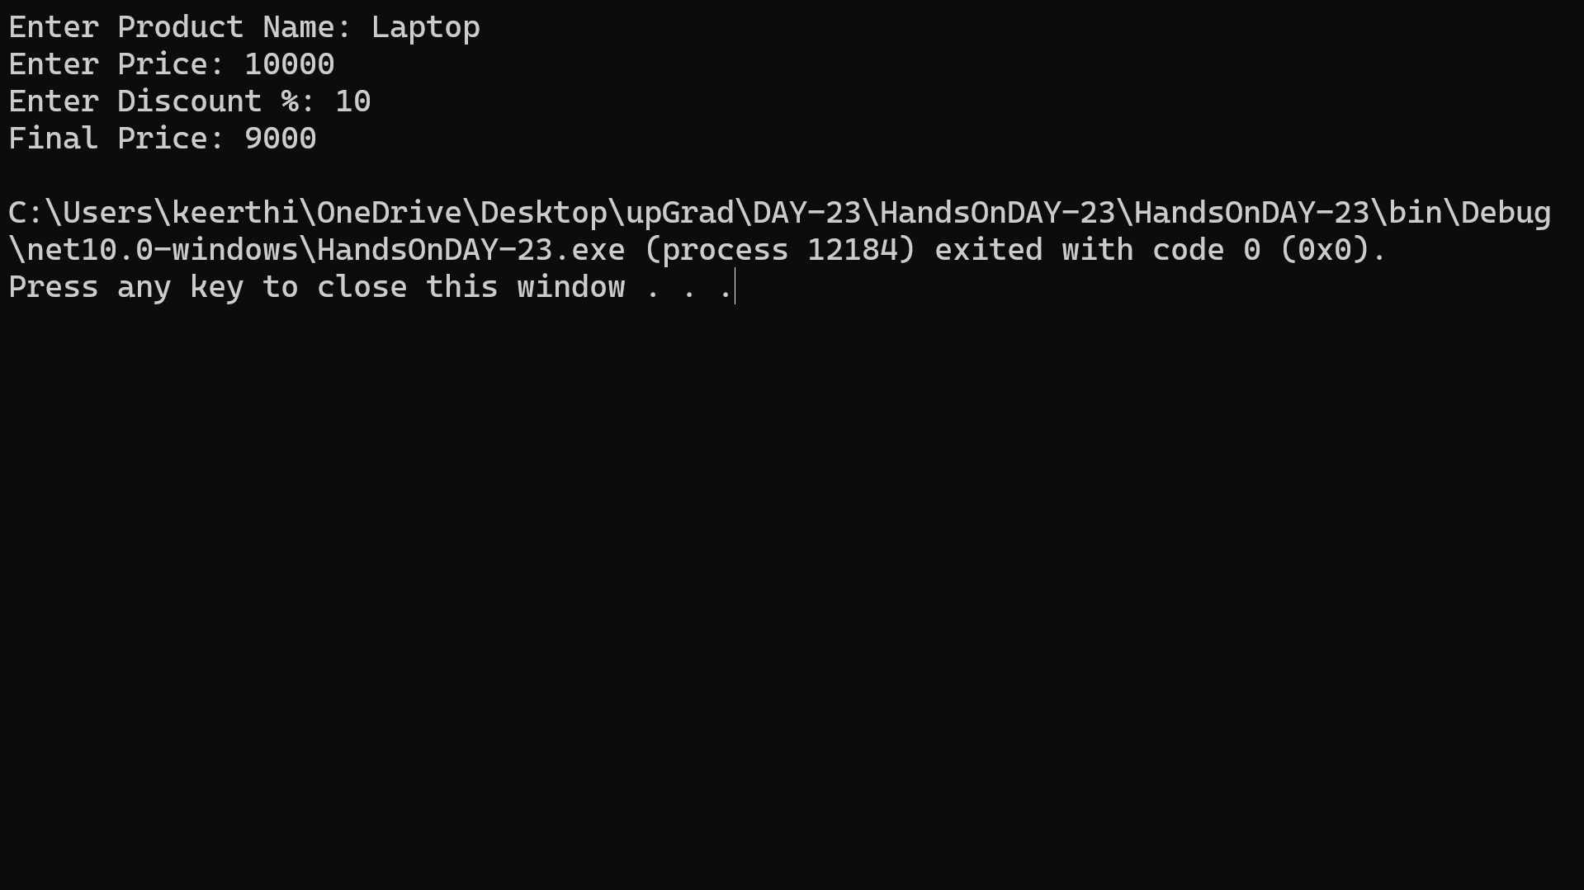
OUTPUT:

Level-2 Problem 3: Application Tracing for Order Processing
Scenario
An e-commerce application processes customer orders. Sometimes the order processing fails, but developers are unable to identify where the failure occurs. The team decides to implement Tracing to monitor the execution flow and diagnose the issue.
Requirements
- Create a console application that simulates order processing.
- The order processing should include the following steps:
  - Validate Order
  - Process Payment
  - Update Inventory
  - Generate Invoice
- Use Trace class to log messages at each step of the process.
- Display trace messages showing the execution flow.
Technical Constraints
- Use System.Diagnostics.Trace.
- Write trace messages using:
  - Trace.WriteLine()
  - Trace.TraceInformation()
- Configure a TextWriterTraceListener to store trace logs in a file.
- Implement the solution using .NET console application.
Expectations
- The application should log messages for each stage of order processing.
- Trace logs should help developers identify where failures occur.
- The trace output should be stored in a log file.
Learning Outcome
Students will learn how to:
- Implement application tracing using System.Diagnostics.
- Monitor application flow using Trace listeners.
- Use trace logs to diagnose runtime issues in real-world applications.
CODE:
using System;
using System.Diagnostics;
using System.IO;

namespace HandsOnDAY_23
{
internal class Problem_05
{
static void Main(string[] args)
{
Trace.Listeners.Add(new TextWriterTraceListener(@"C:\Users\keerthi\OneDrive\Desktop\upGrad\DAY-23\traceLog.txt"));
Trace.AutoFlush = true;

Trace.WriteLine("Order Processing Started");

ValidateOrder();
ProcessPayment();
UpdateInventory();
GenerateInvoice();

Trace.WriteLine("Order Processing Completed");

Console.WriteLine("Tracing completed. Check traceLog.txt");
}

static void ValidateOrder()
{
Trace.TraceInformation("Validating Order...");
}

static void ProcessPayment()
{
Trace.TraceInformation("Processing Payment...");
}

static void UpdateInventory()
{
Trace.TraceInformation("Updating Inventory...");
}

static void GenerateInvoice()
{
Trace.TraceInformation("Generating Invoice...");
}
}
}
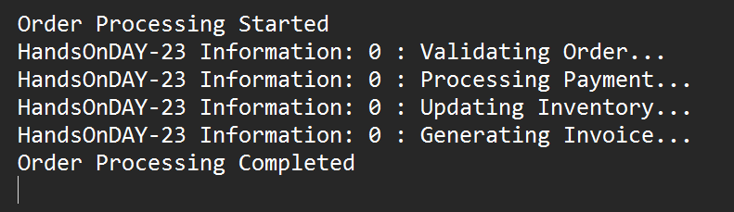
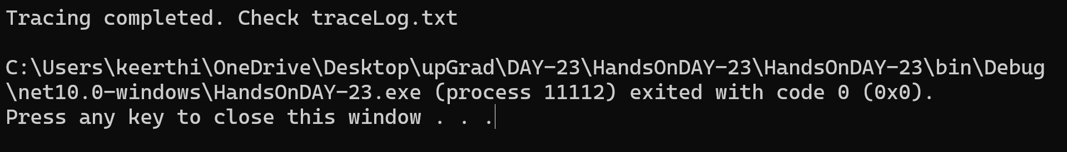
OUTPUT:

